# Upgrading from IIQ 6.4p7 to IIQ 7 to IIQ 7 p1 and p2

## Steps:

1. Take a backup of instance and database of IIQ6.4p7. :

* Open command prompt in administration mode.
* Change path to mysql-bin
* Command:

mysqldump –u root –p “*database name”*>”*filename*”.sql

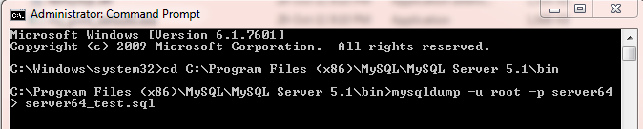

* Backup file will be in mysql-bin.

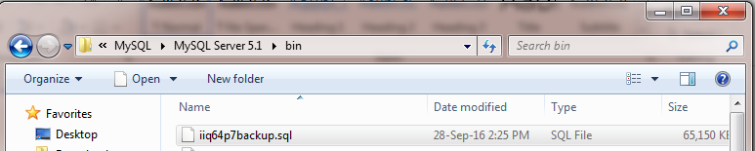

1. Extract IIQ7.0 zip folder and copy all the files to IIQ -> Webapps.
2. Change the database name in
   1. “upgrade_identityiq_tables.mysql”.
   2. “iiq.properties”.
3. Change username and password of datasource in “iiq.properties”.
4. Now open mysql and run script:

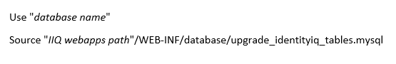

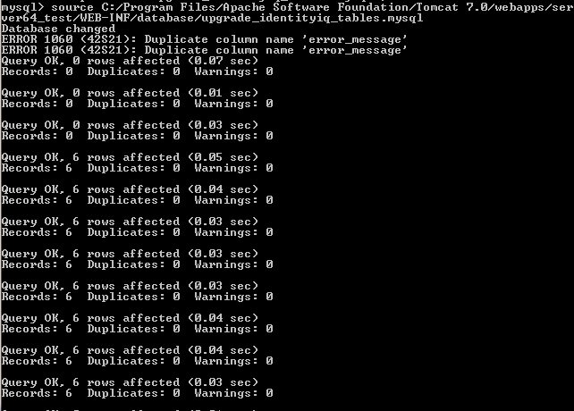

1. Open command prompt in Web-INF and type: “ iiq upgrade”

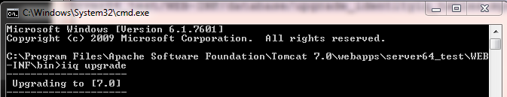

1. IIQ was successfully upgraded from 6.4p7 to IIQ 7.

# Upgrading from IIQ 7 to IIQ 7 p1

## Steps:

1. First download identityiq-7.0p1.jar file from compass in downloads. Before starting the process stop the service.
2. Create folder as iiq-7.0p1.
3. Open command prompt as administrator and give the path of iiq-7.0p1 which we created folder and type the query as below G:\iiq7PatcheFiles\iiq-7.0p1>jar xf ../identityiq-7.0p1.jar.

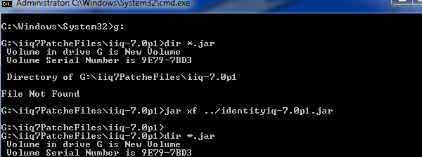

1. Now in iiq-7.0p1 ,in this folder will be getting WEB-INF folder.Copy this folder in to our iiqwebapps🡪iiq7 folder.
2. Go to C:\Program Files\Apache Software Foundation\Tomcat 7.0\webapps\iiq7\WEB-INF\database folder , In that upgrade_identityiq_tables-7.0p1.mysql open this file and give your database name as follows:



1. Now copy the commands given in the above file and paste in mysql command prompt.
2. Go to our iiq folder, WEB-INF🡪bin and open command prompt and type iiq patch 7.0p1

Now will get upgrading successful.

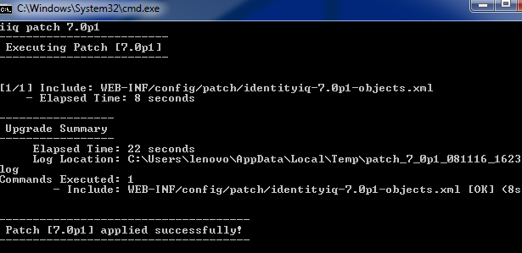

To test whether IIQ is upgraded, Start the service and go to debug.

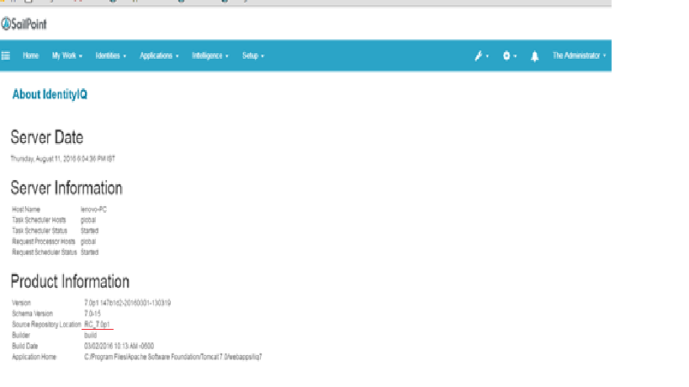

# Upgrading from IIQ 7 p1 to IIQ 7 p2

## Steps:

1. First download identityiq-7.0p2.jar file from compass in downloads. Before starting the process stop the service.
2. Create folder as iiq-7.0p2.
3. Open command prompt as administrator and give the path of iiq-7.0p2 which we created folder and type the query as below G:\iiq7PatcheFiles\iiq-7.0p2>jar xf ../identityiq-7.0p2.jar.

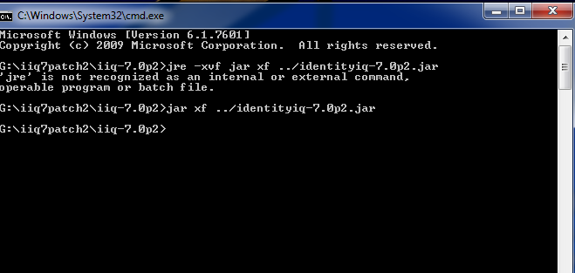

1. Now in iiq-7.0p2 ,in this folder will be getting WEB-INF folder. Copy this folder in to our iiqwebapps🡪iiq7 folder.
2. Go to C:\Program Files\Apache Software Foundation\Tomcat 7.0\webapps\iiq7\WEB-INF\database folder , In that upgrade_identityiq_tables-7.0p2.mysql open this file and give your database name as follows:



1. Now copy this and paste in mysql command prompt.
2. Go to our iiq folder, WEB-INF🡪bin and open command prompt and type iiq patch 7.0p2

Now will get upgrading successful.

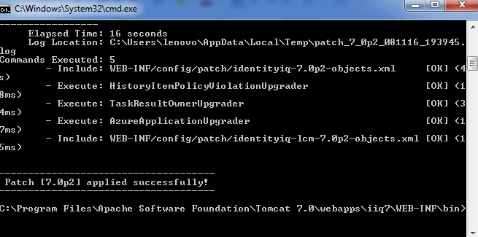

1. To test whether IIQ is upgraded, Start the service and go to debug.